Ultrasonic Sensor Block
ECE44x Wearable Sensor for The Blind Group 34

Keywords—Ultrasonic sensor; water proof; range finder; block description; design verification

Introduction
The purpose of this document is to describe how the ultrasonic sensor being used on the project, to insure that the ultrasonic sensor can be used without any further testing and work as intended. The Ultrasonic sensor will have four pin, which is two for power, 1 for the transmit toggle, and one for the return transmit data toggle. This document will be used to overview of all the function, properties, schematic, and verification of the design, so that the future use of the sensor can be simplyfy.

Block Overview
The Ultrasonic sensor, which will be called module, is a module that transmit and receive sound to detect the distance. .The pwr_spply_ultrsnc_snsr_dcpwr is a power supply to make the module works; it works on 5 DC volts, with 5 mA nominal current. The cntrllr_cd_ultrsnc_snsr_data receive a toggle input from the microcontroller as a string of data in which indicated of what the modul should do, then the module will create a eight pulse signal in which will be transmitted to outer world, then the otsd_ultrsnc_snsr_envin will detect if there is an object within the intended area or not with echo. The echo will toggle off the stream time dealy data that was put when the trigger once set up after a couple microsecond delays, by passing the ultrsnc_snsr_cntrllr_cd_data, the longer the delay to stop the longer it assume the distance. The block diagram of the module system can be seeno on figure 1.

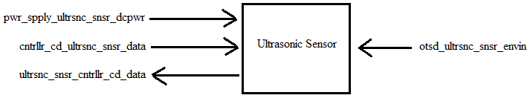
- Black Box Diagram of Ultrasonic Sensor Block
- Display Block Interfaces and Properties
Interface | Properties
otsd_ultrsnc_snsr_envin | 1. Probe Freq.: 40 KHz  2. Range: 20 cm - 500cm  3. Range accuracy : 10cm  4. Angle: 75 degree
pwr_spply_ultrsnc_snsr_dcpwr | 1.Min Voltage: 3 V  2.Max Voltage: 5.5 V  3.Nominal Current: 5mA  4.Peak Current: 30mA
cntrllr_cd_ultrsnc_snsr_data | 1. Pulse Protocol :TTL  2. Pulse Width : 10 us  3. Pulse Voltage: 5 V  4. Messages: Trigger Measurement: 0x55 (1010 1010b)
ultrsnc_snsr_cntrllr_cd_data | 1. Echo Protocol: TTL  2. Echo Width :150 us~25ms (38ms no obstacle)  3. Echo Voltage: 5 V  4. Echo Level During Measurement: 1

Verification
Based on the interfaces for this block, a verification (testing) process needs to be indicated. This will allow for the final constructed design to be tested verifying that all of the interface properties have been met and that the block is ready for integration into the system

Range finder Testing
This test will verify that viewers/users are able to identify the target distance.
- Connect the Module block to power via the pwr_spply_ultrsnc_snsr_dcpwr interface at 5V. Insert a current meter (DMM) inline OR use a power supply that displays the used current.
- Connect a microcontroller to the cntrllr_cd_ultrsnc_snsr_data (trigger) and ultrsnc_snsr_cntrllr_cd_data (Echo) interface.
- Place the module on a height and flat vertical surface.
- Let the program do the range finder on a specific location of object and notify the distance of the object.
PASS: This test passes if 9 out of 10 results have the measurement of the object distance within the 10cm error margin.
Link to Video

Power Testing
To test this, we will put the target object in near approximation, therefore the dealy of return will be shorten, and the power drawn will be greaten.
- Connect the Module block to power via the pwr_spply_ultrsnc_snsr_dcpwr interface at 5.5V. Insert a current meter (DMM) inline OR use a power supply that displays the used current.
- Connect a microcontroller to the cntrllr_cd_ultrsnc_snsr_data (trigger) and ultrsnc_snsr_cntrllr_cd_data (Echo) interface.
- Run the program.
- Put the object within close range proximity, around 0 cm to 30 cm. note the power drawn from pwr_spply_ultrsnc_snsr_dcpwr.
- Set the pwr_spply_ultrsnc_snsr_dcpwr input voltage to 3V and repeat steps 1 – 4.
PASS: This test passes if during both runs, the pwr_spply_ultrsnc_snsr_dcpwr interface never exceeds 30mA.
Link to Video

Sending Testing
This test will focus on the timing of the ultrsnc_snsr_cntrllr_cd_data interface. It will only be tested at a single voltage as the communication should not be affected by voltage. However, the voltage will be the lowest of the possible input voltages as this is the most likely voltage to cause the system to fail timing requirements.
- Connect the Display block to power via the pwr_spply_ultrsnc_snsr_dcpwr interface at 3V.
- Connect a microcontroller to the ultrsnc_snsr_cntrllr_cd_data interface. Connect an oscilloscope to the signal line in the interface.
- Run the program, and put an object in close range proximity (30 cm or less).
- Set the oscilloscope to capture a single sample at a time/div of approximately 10uS.
- Reset the system and ensure a sample is captured that includes the full transmission packet.
- Set the pwr_spply_ultrsnc_snsr_dcpwr input voltage to 5.5V and repeat steps 1 – 5
PASS: This test passes if the data is within 10 uS long data stream in 3 v or 5.5 v.
Link to Video

Reciving Testing
This test will focus on the timing of the cntrllr_cd_ultrsnc_snsr_data interface. It will only be tested at a single voltage as the communication should not be affected by voltage. However, the voltage will be the lowest of the possible input voltages as this is the most likely voltage to cause the system to fail timing requirements.
- Connect the Display block to power via the pwr_spply_ultrsnc_snsr_dcpwr interface at 3V.
- Connect a microcontroller to the cntrllr_cd_ultrsnc_snsr_data interface. Connect an oscilloscope to the signal line in the interface.
- Run the program, and put an object in close range proximity (30 cm or less) and 5 Meter.
- Set the oscilloscope to capture a single sample at a time/div of approximately 40mS.
- Reset the system and ensure a sample is captured that includes the full transmission packet.
- Set the pwr_spply_ultrsnc_snsr_dcpwr input voltage to 5.5V and repeat steps 1 – 5
PASS: This test passes if the data is within 150 uS to 38ms long data stream.
Link to Video
The block will be categorized as pass, when all the testing was pass.

Design
The Wiring Diagram (Fig. 2) presents the block design, including the interfaces of the block. These interfaces are further elaborated through validation information given in Table 2, which demonstrates externaly-supported validy for each of the block’s properties. While the Pulse diagram (Fig.3), is to demonstrated how the ultrasonic module pulse works.

Wiring Diagram
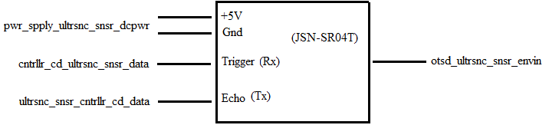
- Wiring Diagram for the Ultrasonic Module Block

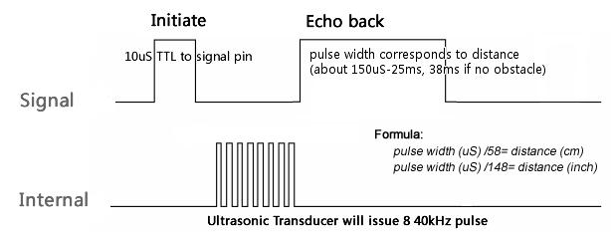
- Pulse Diagram for the Ultrasonic Module Block

Design Validation
For this block, the Ultrasonic sensor Module that being chooses is JSN-SR04T sensor. That sensor was chosen because it fits the water resistance, distance measurement, accuracy, and the angle of detection. The table below (Tabel2), will validate the needed of each block
.

- Interface Property Validation for the ultrasonic sensor Block
Property | Validation
pwr_spply_ultrsnc_snsr_dcpwr
Min Voltage: 3 V | Datasheet specification said min voltage is 3 V [1]
Max Voltage: 5.5 V | Datasheet specification said maximum voltage is 5.5 V [1]
Nominal Current: 5mA | Datasheet specification said current nominal is 5mA[1]
Peak Current: 30mA | Datasheet specification said maximum corrent is 30 mA [1]
otsd_ultrsnc_snsr_envin
Probe freq: 40KHz | Datasheet specification said that the frequency of ultrasound is 40KHZ [1]
Range: 20 cm - 500cm | Although the datasheet said it possible to 600cm, what the project needed is 500 cm
Range accuracy : 10cm | Since the accuracy of the object that needed to detect is 1 meter width, 10 cm accuracy will be sufficient enough
Angle: 75 degree | Datasheet specification said that angle of the ultrasonic is 75 degree [1]
cntrllr_cd_ultrsnc_snsr_data
Pulse Protocol :TTL | Datasheet specification said that Tine-to-Life type (TTL) of signal [1]
Pulse width :10 uS | Datasheet specification said width of TTl is 10 uS [1]
Pulse Voltage: 5 V | Based on the usual 1 or 0 , a microcontroller use about 4.5~5.5 volt to identify as 1
Messages: Trigger Measurement: 0x55 (1010 1010b) | Datasheet specification said it transmit a 10101010 data to set the pulse to work [1]
ultrsnc_snsr_cntrllr_cd_data
Echo Protocol: TTL | Datasheet specification said that Tine-to-Life type (TTL) of signal [1]
Echo width :150us~25ms (38ms no obstacle) | Datasheet specification said width of TTl is about 150 uS to 25mS , and 38mS of no obstacle[1]
Echo Voltage: 5 V | Based on the usual 1 or 0 , a microcontroller use about 4.5~5.5 volt to identify as 1
Echo Level During Measurement: 1 | Datasheet specification said it need to transmit a time delay to microcontroller to calculate the distance [1]

- bill of materials

REFERENCES

- Adruino, “JSN-SR04T 20-60 0cm ultrasonic waterproof Range Finder ” JSN-SR04T Datasheet, https://drive.google.com/a/oregonstate.edu/file/d/1mWfcWH5f5-8lk2r7KeLZ4dzk0CqiVCk0/view?usp=sharing

